List out the required processes to be coded along with the required flow charts
Table of Contents

1.) User Registration Process 2
1.1) Flowchart Description 2
1.2) Key Steps: 2
2) User Login Process 3
2.1) Flowchart Description 3
2.2) Key Steps: 3
3.) Expense Tracking Process 3
3.1) Flowchart Description: 3
3.2) Key Steps: 3
4.) Geographic Area Monitoring 3
4.1) Flowchart Description: 3
4.2) Key Steps: 3
5.) Budget Allocation 4
5.1) Flowchart Description: 4
5.2) Key Steps: 4
6.) Alert Generation 4
6.1) Flowchart Description: 4
6.2) Key Steps: 4
7.) User Settings and Preferences 4
7.1) Flowchart Description: 4
7.2) Key Steps: 4
8.) Security and Data Privacy 5
8.1) Flowchart Description: 5
8.2) Key Steps: 5
9.) User Feedback and Support 5
9.1) Flowchart Description: 5
9.2) Key Steps: 5
10.) App Maintenance and Updates 5
10.1) Flowchart Description: 5
10.2) Key Steps: 5

User Registration Process

  - Flowchart Description: This flowchart illustrates the steps involved in the user registration process, including user input, validation, and database storage.

Key Steps:
- User provide personal details.
- User selects a username and password.
- Input validation and error handling.
- User data stored in the database.
- Confirmation of successful registration
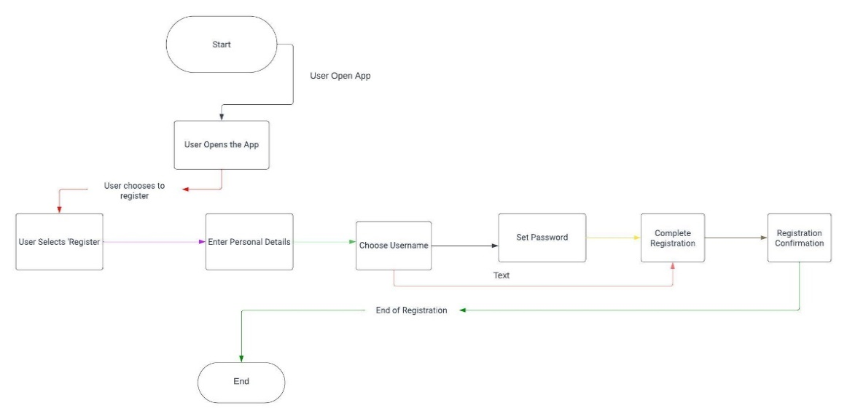
Figure 1 User Registration Process

2) User Login Process
2.1) Flowchart Description: This flowchart outlines the steps for user login,
including authentication and session management.

2.2) Key Steps:
- User enters username and password.
- Authentication against stored credentials
- Session management (E.g., generating session tokens).
- Redirecting authenticated users to the app dashboard.

Expense Tracking Process
3.1) Flowchart Description: This flowchart illustrates how users input and track their expenses using manual or voice recognition modes.

3.2) Key Steps:
- User select expense tracking mode.
- Manual entry or voice recognition input.
- Expense data validation.
- Storage of expense mode.
- Real-time calculation of expenses within geographic areas.

Geographic Area Monitoring
4.1) Flowchart Description: This flowchart demonstrates the process of tracking user’s geographic locations and comparing them to predefined areas.

4.2) Key Steps:
- Continuous GPS tracking of user’s location.
- Comparison with predefined geographical zones.
- Detection of area changes.
- Real-time expense calculation within specific zones.

Budget Allocation
5.1) Flowchart Description: This flowchart explains how the app suggests budget allocations based on spending patterns and goals.

5.2) Key Steps:
- Analysing user's spending history.
- Identifying unmet financial needs.
- Suggesting optimal budget allocations.
- User confirmation or modification of suggestions.

6.) Alert Generation
6.1) Flowchart Description: This flowchart depicts how the app generates alerts for various scenarios, such as overspending or approaching budget limits.

6.2) Key Steps:
- Monitoring user spending in real-time.
- Evaluating spending against predefined limits.
- Generating alerts for specific triggers (e.g., overspending).
- User notification and alert management.

User Settings and Preferences
7.1) Flowchart Description: This flowchart outlines the user interface for configuring notification preferences, security settings, and geographic zones.

7.2) Key Steps:
- User accessing settings menu.
- Configuring notification preferences.
- Updating security settings (e.g., password changes).
- Defining geographic zones and budgets.

Security and Data Privacy
8.1) Flowchart Description: This flowchart details the app's security measures, including data encryption, access controls, and incident response.

8.2) Key Steps:
- Data encryption during transmission and storage.
- Role-based access control (RBAC).
- Incident detection and response procedures.
- User data protection and privacy policies.

User Feedback and Support
9.1) Flowchart Description: This flowchart shows how users can provide feedback, request support, or report issues within the app.

9.2) Key Steps:
- User access to feedbacks and support options.
- Submitting feedback or support requests.
- Appropriate routing of user inquiries.
- Response and resolution processes.

App Maintenance and Updates
10.1) Flowchart Description: This flowchart outlines the procedures for app maintenance, software updates, and version control.

10.2) Key Steps:
- Scheduling maintenance and updates.
- Notification of downtime to users.
- Backup and restoration processes.
- Version control and release management.

